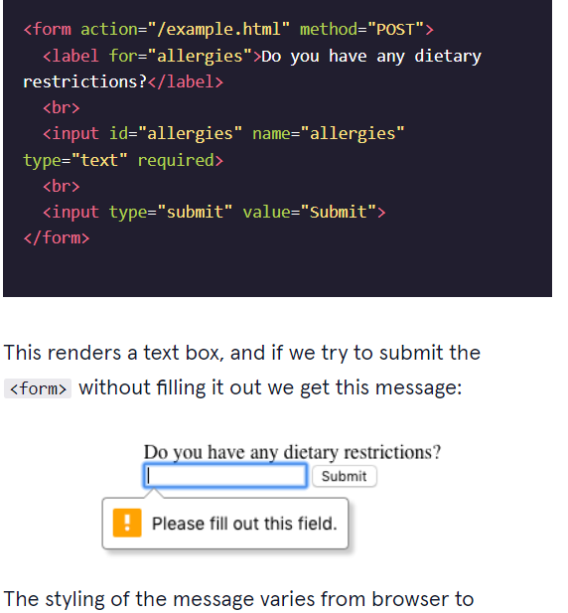

        <input type="number" name="guess" id="guess" required min="1" max="10">

<!DOCTYPE html>

<html lang="en" dir="ltr">

  <head>

    <meta charset="utf-8">

    <title>Sign Up Page</title>

    <link rel="stylesheet" href="style.css" type="text/css">

    <link href="https://fonts.googleapis.com/css?family=Fjalla+One" rel="stylesheet">

  </head>

  <body>

    <section class="overlay">

      <h1>Sign Up</h1>

      <p>Create an account:</p>

      <form action="submission.html" method="GET">

        <!--Add the minlength and maxlength attributes to the input fields-->

        <label for="username">Username:</label>

        <br>

        <input id="username" name="username" type="text" required>

        <br>

        <label for="pw">Password:</label>

        <br>

        <input id="pw" name="pw" type="password" required>

        <br>

        <input type="submit" value="Submit">

      </form>

    </section>

  </body>

</html>

<!DOCTYPE html>

<html lang="en" dir="ltr">

  <head>

    <meta charset="utf-8">

    <title>Sign Up Page</title>

    <link rel="stylesheet" href="style.css" type="text/css">

    <link href="https://fonts.googleapis.com/css?family=Fjalla+One" rel="stylesheet">

  </head>

  <body>

    <section class="overlay">

      <h1>Sign Up</h1>

      <p>Create an account:</p>

      <form action="submission.html" method="GET">

        <!--Add the minlength and maxlength attributes to the input fields-->

        <label for="username">Username:</label>

        <br>

        <input id="username" name="username" type="text" required minlength="3" maxlength="15">

        <br>

        <label for="pw">Password:</label>

        <br>

        <input id="pw" name="pw" type="password" required minlength="8" maxlength="15">

        <br>

        <input type="submit" value="Submit">

      </form>

    </section>

  </body>

</html>

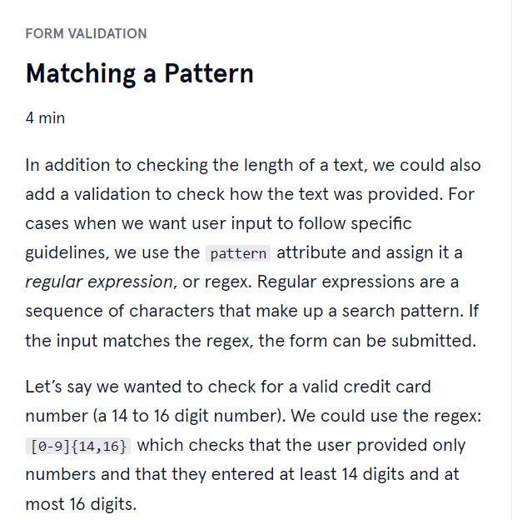

Awesome job adding client-side validation to <form>s!

Let’s quickly recap:

* Client-side validations happen in the browser before information is sent to a server.
* Adding the required attribute to an input related element will validate that the input field has information in it.
* Assigning a value to the min attribute of a number input element will validate an acceptable minimum value.
* Assigning a value to the max attribute of a number input element will validate an acceptable maximum value.
* Assigning a value to the minlength attribute of a text input element will validate an acceptable minimum number of characters.
* Assigning a value to the maxlength attribute of a text input element will validate an acceptable maximum number of characters.
* Assigning a regex to pattern matches the input to the provided regex.
* If validations on a <form> do not pass, the user gets a message explaining why and the <form> cannot be submitted.

When we are using a method=”get’’ = in the link will appear the one that output value:

If it using method=’’post’’ = will NEVER appear the one that output value